Answer the following questions to complete this assignment:
- What does a value of 0 mean for weekday?
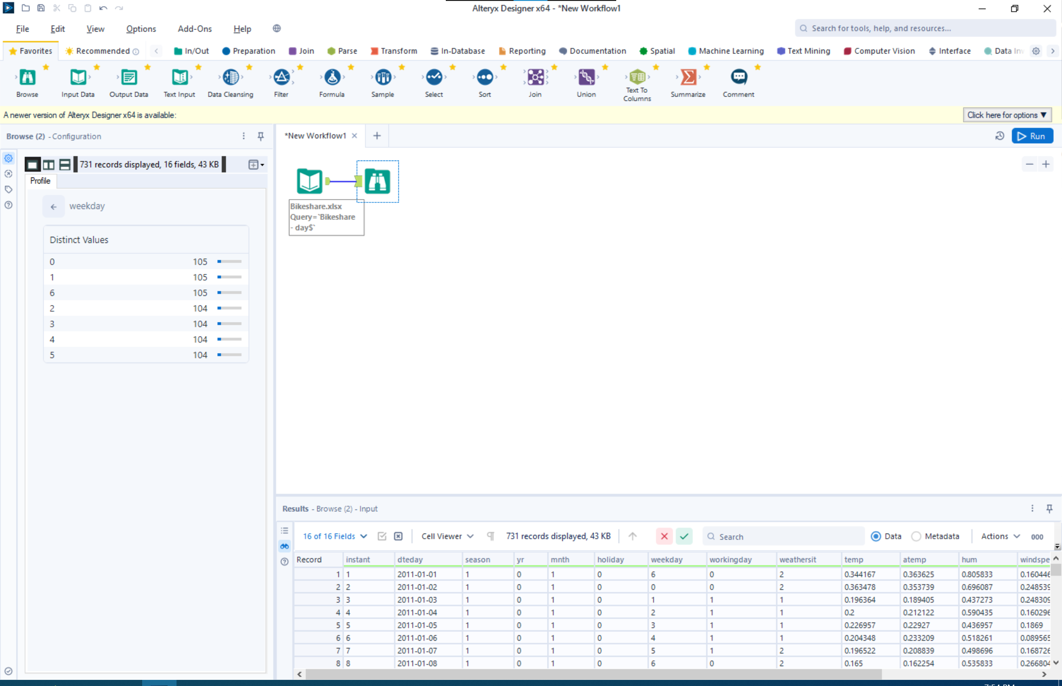
The ‘weekday’ column uses values from 0 to 6. In most programming and data indexing standards, counting starts at 0 rather than 1. Based on that, it’s reasonable to assume that the value of 0 represents Sunday in this dataset.
- Are there any columns that are unclear?
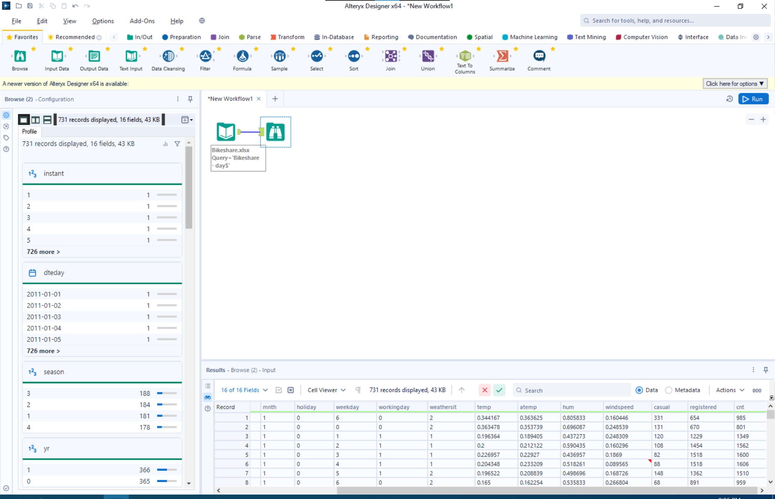
Based on the values and naming conventions, some columns are unclear. For example, ‘weathersit’ ranges from 1 to 3 but doesn’t specify what each value represents. The atemp column isn’t immediately clear without knowing it refers to “feels-like temperature.” While hum likely stands for humidity, that abbreviation isn’t ideal for presentation clarity. The meaning of casual isn’t obvious, it could refer to casual riders, but that isn’t stated directly. Lastly, cnt is an unnecessary abbreviation for “count,” which could be confusing to someone unfamiliar with the dataset.
- What does each record stand for?
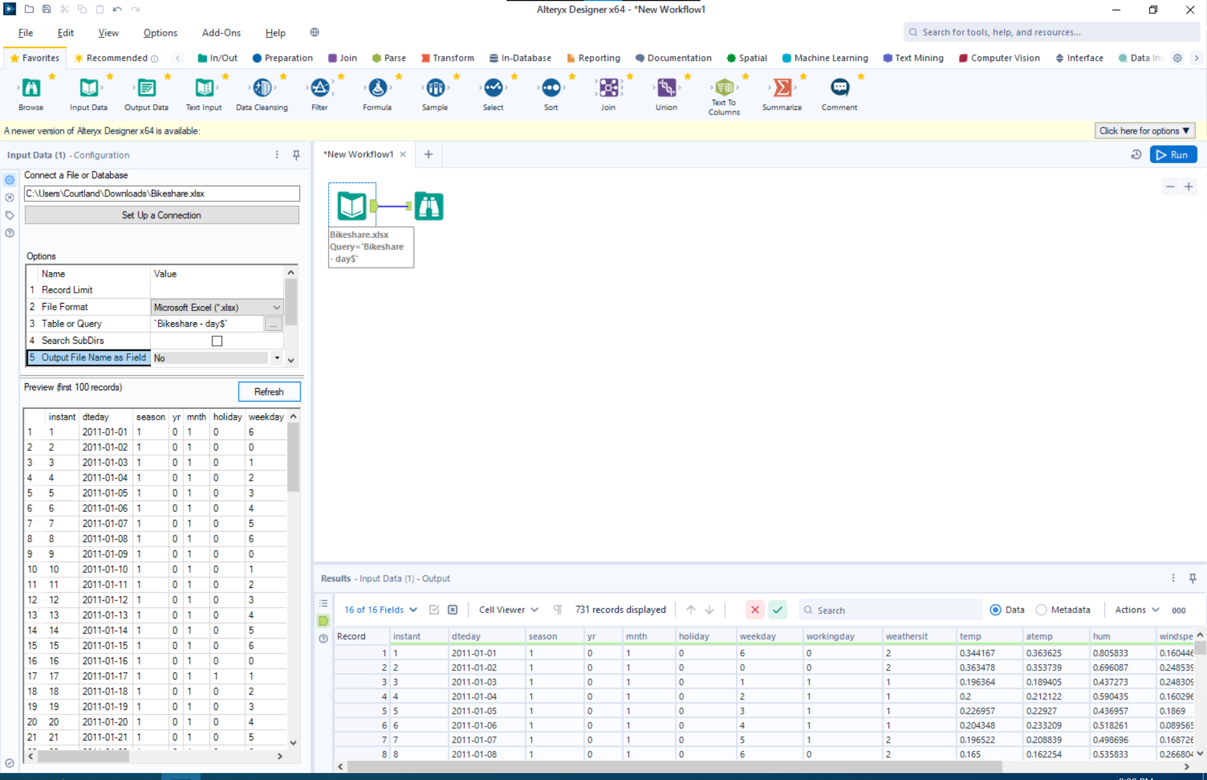
Each record shows a day of activity at the bike rental shop as well as anything that may affect the business for rentals, such as weather, temperature, casual vs registered renters, the day/month/year as well as the day of the week and if it is a holiday or not.
- Is this a sample or population? Please Explain.
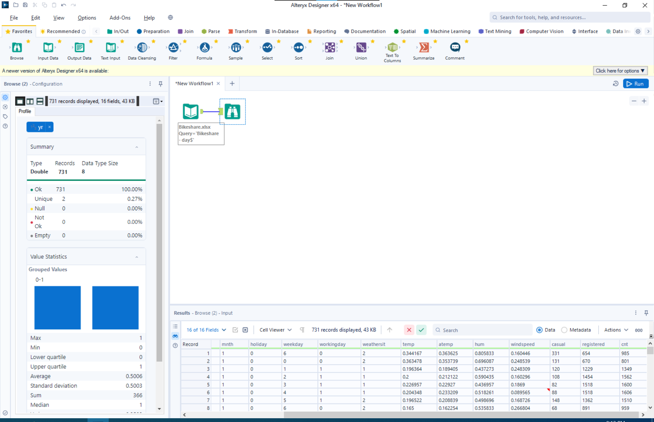
This is a sample dataset, providing the insight of a two year span for bike rentals. It would be easy to assume this was taken from a larger dataset that would house the population data. (Unless this is a brand-new bike rental center)
- How many years of data do we have?
We have two years of data starting from January 1st of 2011 all the way to December 31st of 2012.
- Are there any missing/blank/empty/null values?
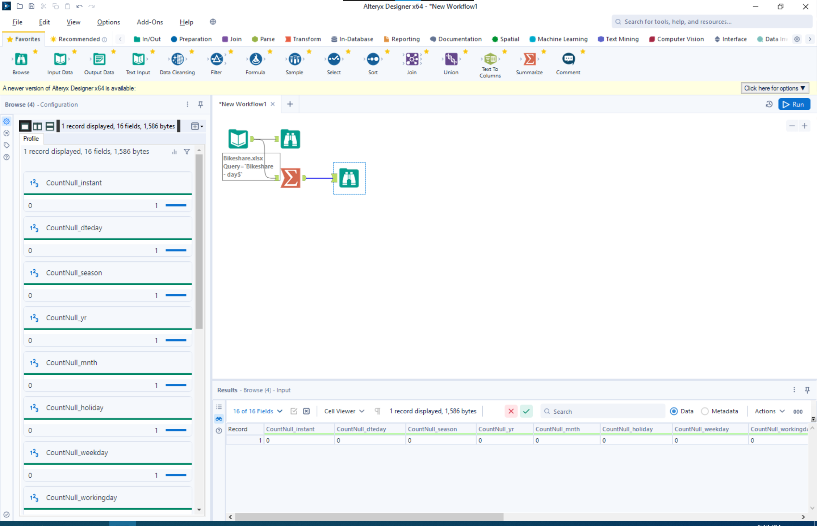
When doing a summarize for all fields where the count of all null values is pulled, it comes up with no counts across all fields.
- What was the average daily number of bikes rented (cnt) for both kinds of users?
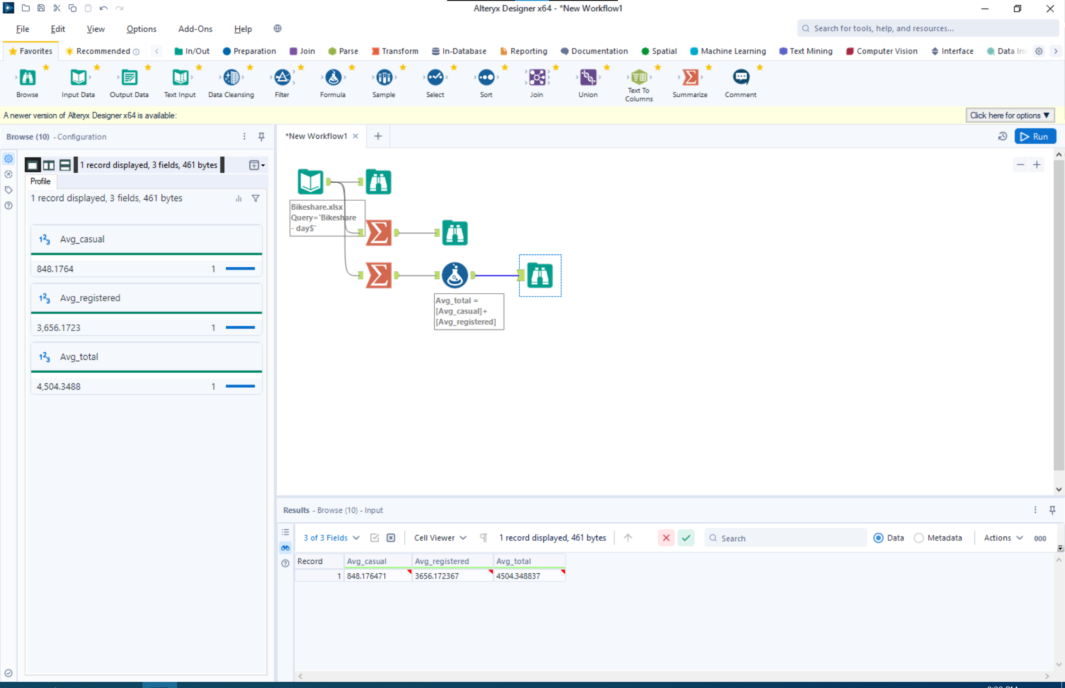
The average cnt for casual users is about 848, the average cnt for registered users is about 3656, and the average cnt for both users is about 4504.
- What about the max and min?
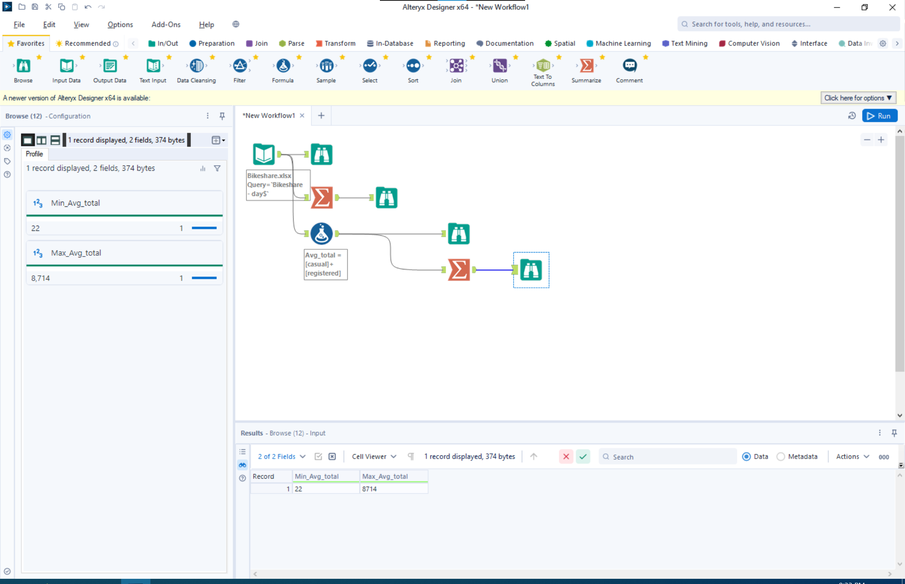
The min is 22 rentals in a day and the max is 8714 rentals in a day.

